Predator and Prey: The mathematics of a balanced ecosystem

Rebecca Brady, John S Butler

[John.s.butler@tudublin.ie](mailto:John.s.butler@tudublin.ie)

**Abstract**

**Introduction**

Understanding how animal populations change over time and interact with other animals and their environment helps with the preservation of animals. Investigating and modeling the relationship between predators (animals that hunt and eat other animals) and prey (the animal that is food for the predators) helps use understand the natural ups and downs of a population to when it could be at risk of extinction. To do this successfully we need data to see what is happening and mathematics to model and predict what might happen. In this paper we will show how addition, subtraction and multiplication can be used to model the predator-prey relationship seen in the wild.

**Data**

Good models start with good data. Interestingly one of the first observations of this up and down was by a company that was hunting both the predator and prey for their fur in the 19th and 20th century. The Hudson Bay Company made yearly records of the amount of snow lynx and snowshoe hare pelts they collected. Figure 1 shows data for the number of hare pelts in green over time top row and the Lynx pelts over time in red bottom row. The data showed that some years there were more lynxes (predators) but less hares (prey) like 1927 while other years, like 1932 there were more hares but less lynxes.

The up and down in the hare and lynx population over time might suggest that there is a relationship between the two animals, which makes sense as the lynxes eat the hares. When there are more lynxes, they eat more hares which decreases the hare population. But when the hare population is low it is hard for the lynxes to find the hares which means less food and results in a decrease in the lynx population. When, the lynx population decreases the hare population will increase again and the up-down cycle will continue. If the predator and prey populations are balanced they will go up and down over time. Up and down like waves, the question a mathematician asks is, “can I explain this using addition, subtraction and multiplication (not even division) and can I predict the future?”.

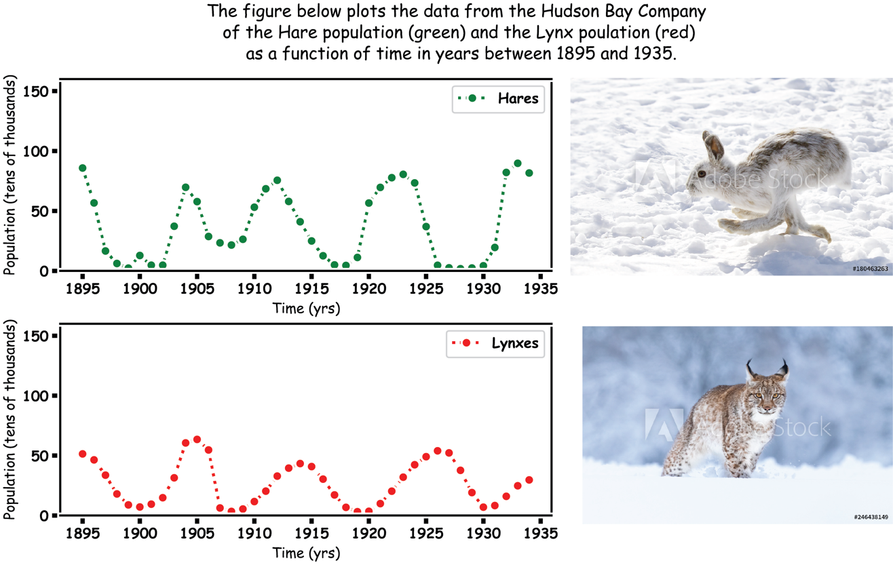

**Mathematical Models**

Mathematicians use equations to describe what people see in the world. The predator prey relationship was first modelled in 1920s by Lotka 1 and Volterra 2. They both noticed the up and down in populations and they wanted to see if they could use mathematics to explain what people seen in the natural world.

**Lotka and Volterra used differential equations to model the general predator prey relationship. Now, when you first come across the differential equations it can look very complicated but all they are is a way for mathematicians to use equations to describe how and what changes populations. A famous mathematician called Euler said that differential equations could just be written as plusses and minuses and that is what we will show here.**

In this paper we will show how mathematics can be used to model the populations of Lynxes and Hares motivated by the data from the Hudson Bay Company.

***Hares***

Before a mathematician creates an equation, they think about the world. So, let’s think about what is happening to the Hare population over time. The future number of Hares, which in maths we will call HFuture, depends on the number of current hares, HCurrent and the current number of lynxes, LCurrent. Then, we just use addition (+) to add to the population subtraction to (–) take away from the population and a small bit of multiplication (x). It is as simple as that.

If there were no Lynxes, than the Hare population in the future is just equal to the current hare population plus births minus deaths, which we call the growth rate rGrowth and multiply it by the current population. When the growth is positive the population increases, when it is negative the population decreases. This give the formula

HFuture= HCurrent+rGrowthHcurrent ,

putting numbers into the formula, current population is HCurrent=80 hares and the growth rate rGrowth=0.1 then the equation gives

80+0.1*80=88.

If this population keeps growth like this the whole world will be covered in Hares, which is called exponential growth.

**Let’s include the Lynxes, as Lynxes eat the hares, we use subtraction to model this and create the term the eat rate rEat to model how many Hares are eaten by lynxes which is multiplied by the lynx and hare population**.

Now putting numbers into the formula, current hare population is HCurrent=80 hares with a growth rate rGrowth=0.1 a Lynx population of LCurrent 40 and an eat rate of rEat=0.0025 this the equation gives

80+0.1*80-0.0025*80*40=80.

That means the population stays the same as the lynx have eat the same amount as the hares increase. This gives the equation for the hare population now for the lynxes.

**Lynxes**

For the Lynxes if there are no hares then the lynx population would go down so to model this, we use subtraction. The future number of Lynxes is equal to the current number of lynxes minus the death rate rDeath time the current number of lynxes.

LFuture= LCurrent-rDeathLCurrent

Now putting numbers into the formula, current population is LCurrent=40 lynxes and the death rate is 0.025 then the equation gives

40-0.05*40=38,

if this keeps happening after a while there will be no Lynxes.

Now let’s include the hares. The Hares are a food source, so the current hare population is included by multiplying them by the current lynx population times an eat rate rEat.

Putting numbers into the formula, current population is LCurrent=40 lynxes and the death rate is 0.1 with a food rate of 0.00125 and a HCurrent=80 then the equation gives

40-0.05*40+0.00125*40*80=42,

That means the lynx population is going up because of all the food (Hares).

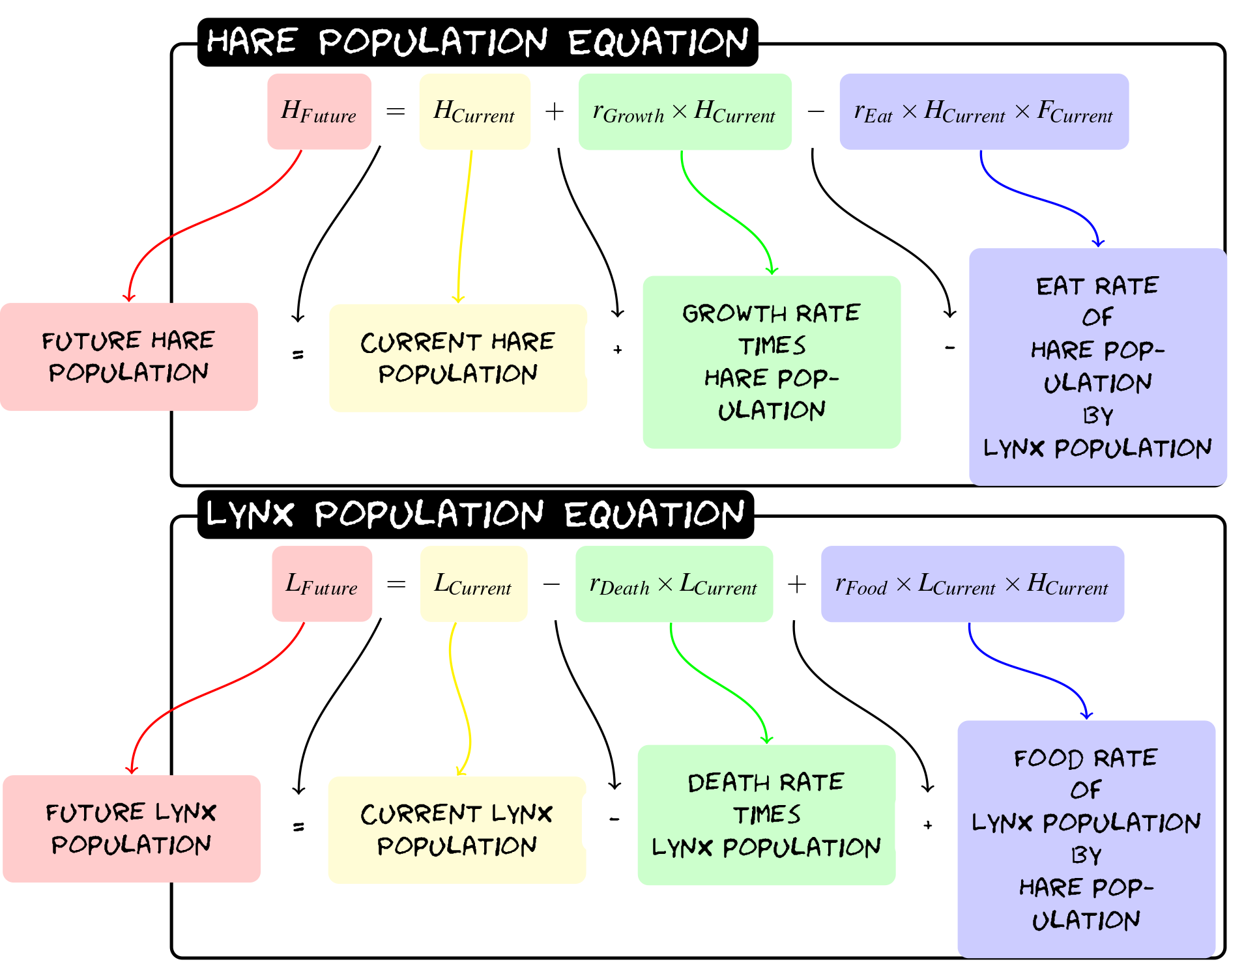

Using the equations we have made for lynx and hares we can model how the Hare and Lynx populations by taking steps in time.

**The Predator Prey-Relationship**

Using computers (the code for this is available at this link [LINK]), we simulate the population the predator prey relationship shown in Figure 2. The plots for the Hare (green) population and Lynx (red) population show the up and downs that are in the real data.

Another way of looking at how two species are related to each other is by plotting them against each other the plot on the right in Figure 2, the x in the middle is the average Hare and average Lynx population. It looks a bit like the orbit of the earth around the sun. The populations go round and round which is the up and down over time. A balanced eco-system that is modeled here the orbits stays stable but if it starts spiraling in or out could be an early warning sign.

**Further Implications**

To do this kind of modelling you need good data to get the numbers to start the model, which means scientist, conservationist and even fur hunters collecting the information is vital.

When mathematicians try to describe something complicated, they simplify things and it is the same for these equations, which means the predictions and simulations do not perfectly follow the original data. Some problems with the simplifications we make are:

1. There is more than one predator of the Snowshoe Hare, what about snow foxes, large birds and many others.
2. Snow Lynxes have a bigger diet than just snowshoe hares, they can also eat other animals to survive, like fish, squirrels and many others.
3. The Snowshoe Hares do not run out of food, which is definitely not true in winter
4. What about human fur hunters, who hunt both lynxes and hares.

To make the equations work for all these other situations you can include extra equations and pluses and minuses. If you have all the data, you could perfectly model the future. Even with these simplifications the mathematics can still do a good job modelling the hare and lynx population.

The mathematics for the predator-prey models has been shown to be very adaptable and useful such that you could change the words Snow Lynx to Shark and Hare to fish and the mathematics will still work with the right data. You could even use the same equations and change the word Lynx to Zombie and Hares to humans which has even be used in a computer games!

The mathematics can also be used to predict the impact or re-introducing a previously extinct animal back into an area like in 1995 when wolves were re-introduced into Yellowstone park with surprising results watch the video []. There were concerns that the re-introduction of wolves would mean that there would be a decrease in the deer and other animals. But it was just the opposite, when the wolves came there was an increase in the population of all the prey and even more because the wolves scared the deer and other animals away from the river bank which mean the plants could flourish again which meant more food for the deer which mean more deer. This was surprising but if they had a model, they could have predicted this amazing increase in all the animal population [5], there has even been a game developed to show how this happened go to <https://ecobuildergame.org> to play.

This predator prey relationship can be expanded further outside of just animals and can be use to model how companies interact, chemical reactions, and how viruses spread. You can read more about this in another Frontiers for Young Minds paper by [CITE] which talks about using similar mathematics to model and understand the spread of COVID 19.

Hopefully you can see how simple mathematics of adding, subtracting and multiplication with a bit of thinking can be used to model and predict the populations of predators and preys.

Reference:

1. Lotka, A. J. Analytical Note on Certain Rhythmic Relations in Organic Systems. *Proc. Natl. Acad. Sci.* **6**, 410–415 (1920).

2. Volterra, V. Fluctuations in the Abundance of a Species considered Mathematically. *Nature* **118**, 558–560 (1926).

<https://ecobuildergame.org>

https://www.youtube.com/embed/ysa5OBhXz-Q

You can also look at the notebook on the negative impact of microplastics to our ecosystem [4].

References

[1] Vito Volterra. Fluctuations in the abundance of a species considered mathematically. Nature,118:558–560,1926.

[2] Wikipedia contributors. (2018, July 27). Lotka–Volterra equations. In Wikipedia, The Free Encyclopedia. Retrieved 09:33, September 7, 2018, from https://en.wikipedia.org/w/index.php?title=Lotka%E2%80%93Volterra_equations&oldid=852191432

[3] Alfred J Lotka. Analytical note on certain rhythmic relations inorganic systems.Proceedings of the National Academy of Sciences,6(7):410–415,1920.

[4] Aleksandra Samotyja, Gordon Chambers, John S Butler, Microplastic as Prey https://github.com/john-s-butler-dit/MicroPlastics

[5] Euler Method (2019, October 20) https://en.wikipedia.org/wiki/Euler_method

[6] Stenseth, N. C., Falck, W., Bjørnstad, O. N., & Krebs, C. J. (1997). Population regulation in snowshoe hare and Canadian lynx: asymmetric food web configurations between hare and lynx. *Proceedings of the National Academy of Sciences*, *94*(10), 5147-5152.

[7] Greens call for wolves to be reintroduced to Ireland (2019, October 20) https://www.irishtimes.com/news/politics/greens-call-for-wolves-to-be-reintroduced-to-ireland-1.4036692

[8] How Wolves Change a River (2019, October 20) https://www.youtube.com/embed/ysa5OBhXz-Q